PowerSearches

API > Empower > EM > PowerSearches has a class for each PowerSearch. Empower draws the PowerSearch window based on the values in the class.
The datasource for the PowerSearch is a View.
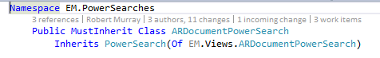
The PowerSearch class defines the Search By columns
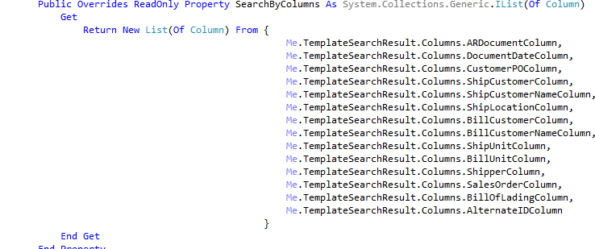

As well as the result columns. The result columns are displayed in the order in which they are listed.
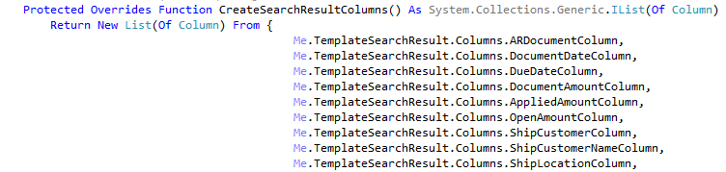

The InitializeColumns subroutine allows you to define search criteria other than Search By and Search For.
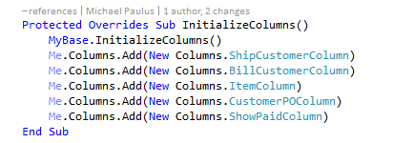

The AppendSearchCriteria subroutine allows you to add the additional search criteria to the database query.
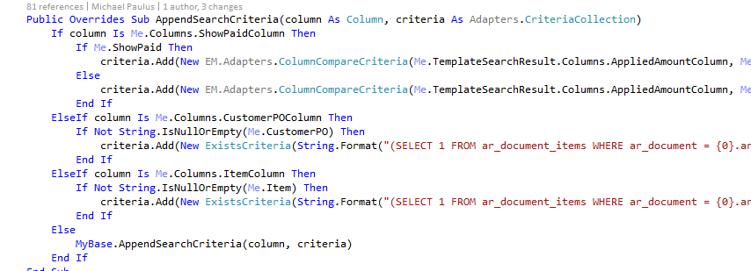

PowerSearch Filters
API > Empower > EM > PowerSearches > Filters has the filters that remove items returned by the PowerSearch view that shouldn’t be included in the displayed PowerSearch rows. See the BankAccountDirectDeposit filter class for an example of this. When selecting rows for the direct deposit file, checks and bank withdrawals that are already on the items grid to be included in the direct deposit file should are eliminated from the displayed PowerSearch rows.

